Output Assignment 1:

Test Door

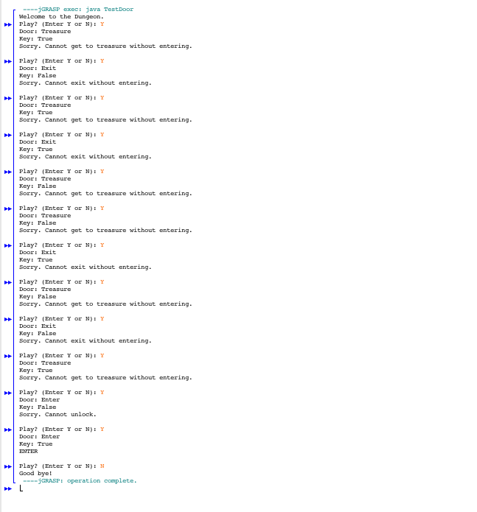

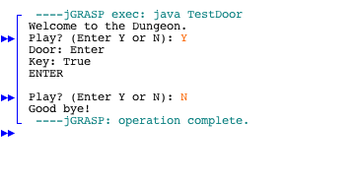

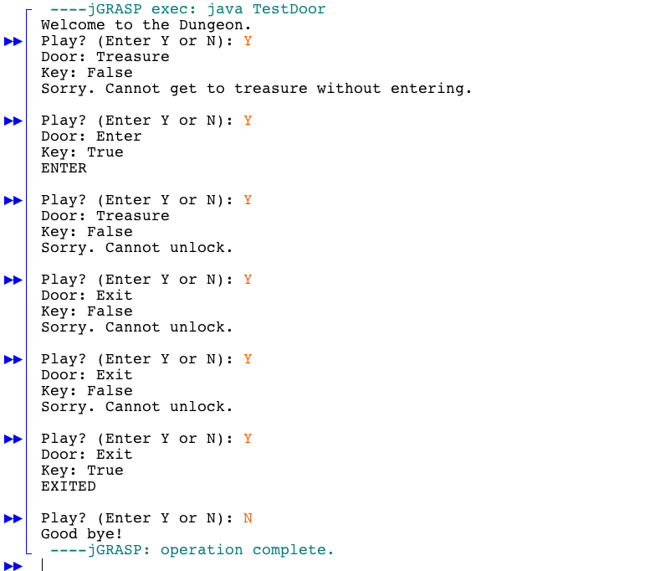

**Source:** This is entirely my own work. Obtained some help from the Teaching Assistant (TA), Class notes, Slides and the Book as well. The sources are provided where applicable

MotorBoat Demo

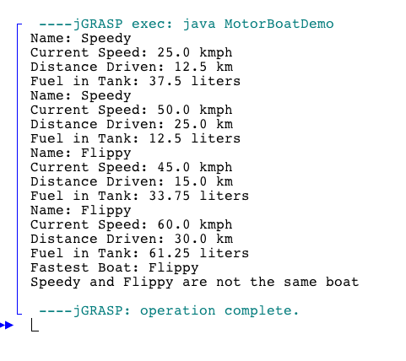

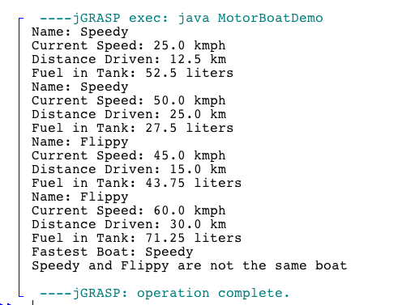

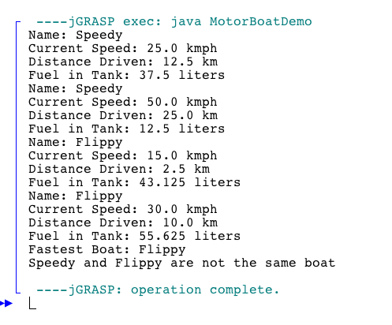

**Source:** This is entirely my own work. Obtained some help from the Teaching Assistant (TA), Class notes, Slides and the Book as well. The sources are provided where applicable.